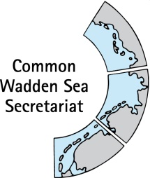

Wadden Sea Board

WSB 20
16 June 2017
Harlingen, Netherlands

__________________________________________________________________________

Agenda Item: 6.1

Subject: Outcome of PCDG 4 Meeting (Bremen, Germany, June 12, 2017)

Document No. WSB 20/6.1/2

Date: 15 June 2017

Submitted by: Secretariat
__________________________________________________________________________

Proposal: The meeting is requested to consider the document and provide guidance as indicated.

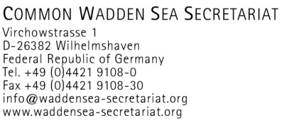

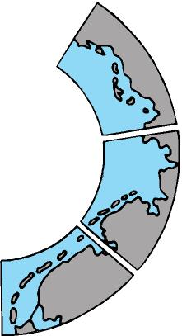
Outcome of the PCDG4, Monday, June 12, 2017

Participants: Rüdiger Strempel (CWSS Chair), Hubertus Hebbelmann (DE, Lower Saxony), Margrita Sobottka (DE, Lower Saxony), Anne Husum Marboe (DK), Thomas Borchers (DE, BMUB) , Bernard Baerends (NL), Kees van Es (NL), Hans-Ulrich Rösner (WWF)

Introduction of the outcome of the HGL+
Regarding the Partnership Hub the HLG+ (May 24, 2017) arrived at the following conclusions. Future discussions regarding the PC should be based on the following premises:
- The Partnership Center should comprise the CWSS and a future Partnership Hub (PH) under the overall (office)management of the Executive Secretary of CWSS;
- CWSS and the PH should have a common governing body, which would comprise the membership of the current WSB for all issues falling under the mandate of CWSS and possibly an extended membership for decisions concerning issues falling into the remit of the PH;
- It needs to be determined what the composition of this possible extended WSB should be;
- The differentiating criterion for the mandate of CWSS and the remit of the PH could possibly be whether the issues concerned are “mandatory” (CWSS) or “non-mandatory” (PH) tasks. To this end, it needs to be clearly defined which tasks of the TWSC and the Wadden Sea Forum fall under which heading;
- The differentiation between “mandatory” and “non-mandatory” tasks as well as the question of the composition of a possible extended WSB should be discussed by the next PCDG, to be held prior to WSB 20 with a view to informing the discussions at WSB 20;
- CWSS is to deliver a paper outlining which tasks are mandatory and which are non-mandatory (taking account also of the work of the WSF);
Following the conclusions the HGL+
- CWSS is to deliver a paper outlining which tasks are “mandatory” and which are “non-mandatory” as a basis for discussion by PCDG 4
- PCDG 4 is to discuss the issue of “mandatory” and “non-mandatory” tasks as well as the possible composition and mode of establishment of a possible extended WSB and to deliver a report to WSB 20

Mandatory and non-mandatory activities in the framework of the TWSC
Paper submitted by CWSS to the PCDG4

Main conclusion of the paper:
- The responsibility for compliance with legal (mandatory) obligations rests individually with the states rather than the TWSC as a whole.
- The Administrative Agreement 2010 (functions of the CWSS) is the only legally binding instrument of the TWSC which defines mandatory activities (narrow interpretation of the term mandatory)
- In a broader interpretation, mandatory tasks can also emanate from the political agreements and declarations of the Cooperation
- Based on this interpretation, the TWSC’s mandatory tasks can be defined by the 2010 JD, the WSP2010 and the various declarations
- This means that most activities currently undertaken are wholly or partially mandatory in the sense of the broader definition.
- This indicates that categorizing activities as mandatory or non-mandatory may not be the most expedient way to determine the mandate of the future partnership element of the Partnership Center
- It is a political rather than a legal decision which activities the Parties wish to assign to the existent intergovernmental segment of the TWSC and which tasks they may see fit to fulfill in the Partnership Hub.

The PCDG4 thanked the Secretariat for the clear paper and agreed on the conclusions of the paper that a clear formal distinction between mandatory and non-mandatory activities of the TWSC is not the most suitable way to distinguish between the tasks of the TWSC and the Partnership Hub.

There was a general understanding that the decision that a given task is to be dealt with by the PH does not necessarily imply that it is no longer dealt with by CWSS/ in the TWSC.

Because it is rather apolitical discussion than a legal one which role and tasks belong to the Partnership Hub, the PCDG4 distinguished the following sectors/partner-networks to be potentially invited to participate in the Partnership Hub and the possible benefit (added value) of the Partnership Hub for these sectors/partner networks. These benefits of the Partnership Hub can differ from sector to sector/partner network to partner network, although there are general benefits of the Partnership Hub for all partners. Accordingly, the role and services provided by the PH may also differ from sector to sector.

Potential sector/partner-networks  for the Partnership Hub | Added value - Role  of the Partnership Hub
All partners | Network facilitation  Exchange information  Project-initiation  Enhanced visibility and raised profile  Political influence
Cultural and landscape | Acknowledgement
Education | Development & providing of educational products  Improve quality + trilateral WH focus
Nature-management / green NGO’s | See ‘all partners’
Regional food production | Platform for innovation  Market access  Acknowledgment
Tourism | Innovation  Co-creation  Enhances sustainability  Regional development
Research | Meeting place (see all partners)  Continual agenda development
Regional shipping and harbors | Innovation
Fishery | Enhances sustainability
Energy / CO₂-neutral | Exchange of good practices (see all partners)

The best way to go forward would be to appoint ‘initiators’ with the tasks to investigate, in close cooperation with the potential sector/partner-networks, the added value, possible tasks of the Partnership Hub for their sector/partner-network, their willingness to support the PH, possibility of trilateral representation in the governing board, etc. (starting with the science, nature-management and tourism sector)
Depending on the expectations of the sector/partner-networks of the benefits of the Partnership Hub, and of course vice versa what the TWSC expect of their input in the Hub and the governing Board, the sectors/partner networks could be invited to engage in the PH.

The PCDG 4 proposes to the WSB that the next steps be:
- Development of TOR or a paper outlining the role and tasks for ‘initiators/facilitators’ to explore with potential partners added value, possible role/task Hub for the partner-network, their willingness to support the Hub, possibility trilateral representation in the governing board, etc
- Appoint (at least for Tourism, NGOs and Research) initiators
- For the WSB to provide guidance on next steps to be taken prior to WSB 21.

Some considerations on a WSB+ as a possible governing body for the future Partnership Hub within the PC
Paper submitted by CWSS to the PCDG4

The meeting of the HLG+ determined that the future Partnership Center should comprise the CWSS and a Partnership Hub as independent but related entities under the overall office-management of the Executive Secretary of CWSS. Moreover, the HLG+ was of the opinion that CWSS and the PH should have a common governing body, which would comprise the membership of the current Wadden Sea Board (WSB) for all issues falling under the mandate of CWSS and possibly an extended membership for decisions concerning issues falling into the remit of the Partnership Hub. The HLG+ felt that it needs yet to be determined what the composition of this possible extended WSB should be. Therefore, it instructed the PCDG 4, to discuss options for the composition and mode of establishment of an extended WSB:

The PCDG considered several options for the institutional structure and composition of the governing body (cf. diagram).
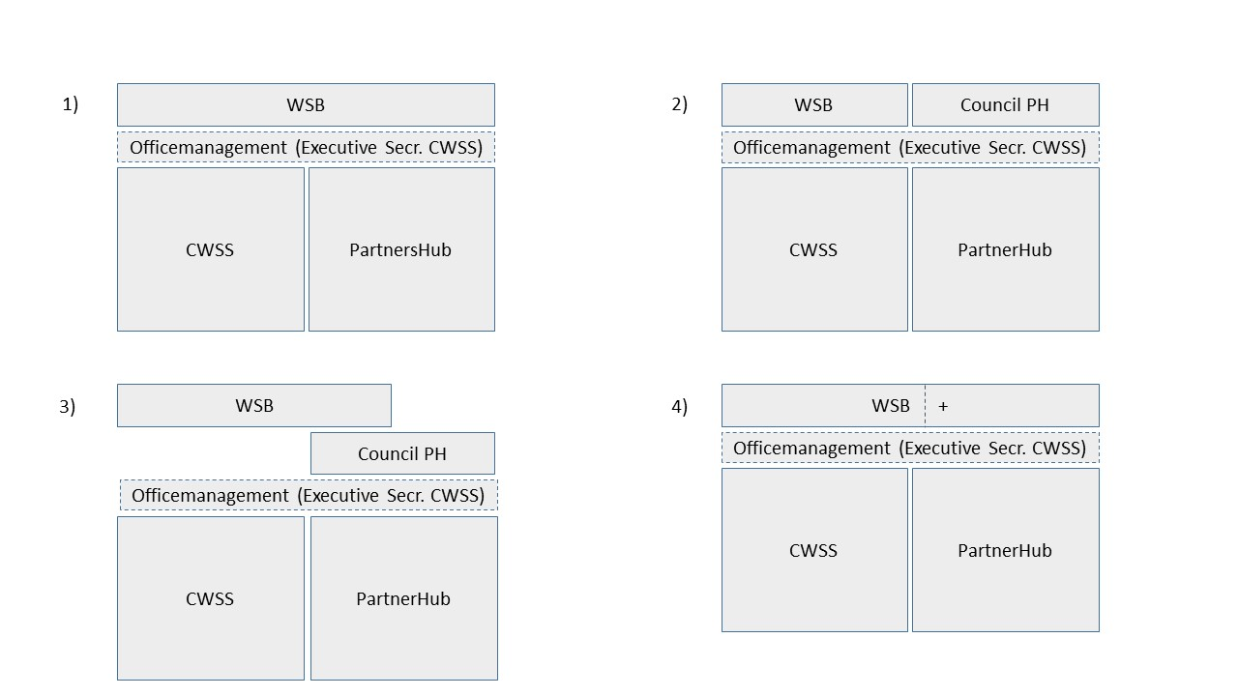

In general Germany and the Netherlands are in favor of model no. 4 (simple, no extra structures, partnership means equal membership, back to back-meeting). Denmark will consider the proposal.

In general the PCDG4 proposes to the WSB to consider the following points:

- The WSB will be enlarged by partner group sector representatives
- Representatives of all relevant sectors/partner-networks, which do not currently have a permanent voice in the WSB, could be admitted in the WSB+. Depending on the potential sector/partner-networks who wish to join the Partnership Hub the maximum number of members of the thus enlarged WSB would be 22 (1 chair, 4 members from each State party and one member each (meaning currently up to 9 members) from potential sectors/partner networks). Further considerations for a maximum of the WSB+ are needed to ensure that a practical and workable size of the WSB+ is maintained
- Each sector/partner-network group is trilaterally represented by one representative (under the condition that they are trilaterally coordinated). The selection of representatives is left to the sector/partner-networks concerned.
- Sector/partner-network representatives should ideally be full members of the WSB+ rather than merely advisors for decisions concerning issues falling into the remit of the Partnership Hub
- In principle the WSB+ strives for decision-making by consensus. Both the representatives of the States Parties and the representatives of the sector/partner-networks are members of the WSB+. However, only the States Parties (meaning any one State Party) can veto a possible decision if a decision is in conflict with their obligations, in particular legal obligations and policy goals. The precise modalities for decision-making within the WSB+ should be laid down in the rules of procedure of the enlarged WSB as the governing body for TWSC and Partnership Hub.

