Operational Team Partnership Hub
OPteamPH 15
12.03.2020
Hamburg
__________________________________________________________________________________
Agenda item: 4.1
Subject: Draft vacancy announcement project officer Wadden Sea World Heritage
Partnership Hub
Date: 06.04.2020
Submitted by: chair
__________________________________________________________________________________
Covernote:
The meeting is invited to finally comment on the draft advert.
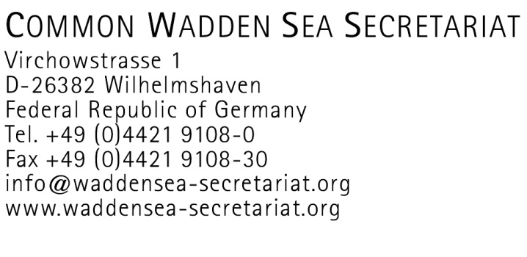

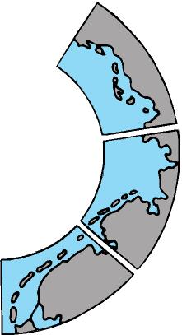
Project Officer, Wadden Sea World Heritage Partnership Hub
(draft Vacancy Announcement No. xx/20; version 06.04.2020/MS/BB + commented track changes by OPteamPH members)

The Common Wadden Sea Secretariat (CWSS) in Wilhelmshaven, Germany, is the Secretariat of the Trilateral Wadden Sea Cooperation (the Danish, Dutch, German cooperation at government level for the protection of the Wadden Sea, TWSC) and partner in the trilateral, strategic, multi-stakeholder “Trilateral Partnership in support of the UNESCO Wadden Sea World Heritage”. The Secretariat is located in Wilhelmshaven, Germany. The working language of the partnership, the TWSC and CWSS is English.

CWSS is seeking to recruit, as soon as possible, a

Project Officer (m/f/d), Wadden Sea World Heritage Partnership Hub

In 2019, several organisations and networks from the green NGOs, the research and education sector, the tourism sector, the Wadden Sea (stakeholder) Forum and the TWSC founded the “Trilateral Partnership in support of the UNESCO Wadden Sea World Heritage” (Link to webpage with MOU). To support this partnership in terms of organisation and management, a Trilateral Partnership Hub (PH) for the Wadden Sea World Heritage is currently under development. The Mission of the PH is to broaden engagement for the Wadden Sea World Heritage beyond the state sector by unlocking potentials and resources and to extend the partnership for delivering on the goals and intended activities of the partnership. During a three-year’s start-up phase (2020-22), the PH shall be further established. This activity is partly co-funded by the EU Interreg VB North Sea Programme, as input to the PROWAD LINK project. The incumbent’s task will be to actively explore stakeholder networks in Denmark, Germany and the Netherlands which might fit in and merit from the Trilateral Partnership. He/she will act as project officer for the PH, to join a core team which operates the start-up phase of the PH, associated to the CWSS, and to provide support to the trilateral working group of the partners, the Operational Team Partnership Hub. This is a full-time post covering a broad range of partnership-related communication and interaction with a wide variety of stakeholder organisations and -networks across the Wadden Sea region, as well as coordinative issues, including project-development .

Key responsibilities
The Project Officer’s general objectives are to implement and support the execution of the Partnership Hub functions and to contribute to the continuous improvement of network operations in the trilateral partnership and the overall performance of the PH. These are to be fulfilled by performing the following tasks:
Working in close cooperation with the TWSC and other partners in the partnership, in accordance with their decisions, the incumbent will

- Communicate, inform and promote about intentions, ideas and activities of the partnership to various target audiences, on diverse occasions and via media;

- Develop and initiate ideas, organise and support the planning process for partnership-related initiatives and projects and partners’ applications for funding by third parties;
- Explore the potential for new strategic partners from various sectors, e.g. chambers of commerce / business associations in the Wadden Sea region;
- Support the Operational Team Partnership Hub/ respective trilateral groups/working group(s) of the partnership, in a timely and effective manner, f. e. reports to the Wadden Sea Board;
- Contribute to review and update the Concept for the Partnership Hub;

- Carry out other tasks as assigned.

Qualifications required

- Masters-level university degree in environmental science, sustainability management, landscape architecture or a related discipline. A degree in another field with relevant work experience may be accepted in lieu of the above requirements;
- Experience in environmental policy, network-/ collaboration management and nature protection and sustainable development, preferably at the international level;
- Experience of or proven interest in international cooperation, knowledge of and experience with the UNESCO World Heritage Convention is an asset;
- Proven track record in project management, including international/multinational projects;
- Experience in report writing;
- Excellent English drafting skills;
- Experience in handling international projects;

- Proficiency in spoken and written English. Knowledge of another Wadden Sea languages (German, Danish, Dutch) is an asset;
- The incumbent will be an engaged self-starter and a client-oriented team player and networker and will be capable of transferring ideas into project-development;
- Interpersonal skills will include the ability to cooperate with partners from various sectors across the Trilateral Cooperation on the protection of the Wadden Sea and externally;
- The incumbent will possess confidence in representing the partnership vis-à-vis external partners and stakeholders, including public speaking as necessary.
- Candidates must be prepared to travel.

Salary and allowances:
Based on the German Collective agreement for Civil Service Employees (Tarifvertrag für den öffentlichen Dienst, TVöD), depending on qualification and experience comparable up to level 13.

Duration of appointment:
This is a fixed-term contract for one year, with employment foreseen through June 30, 2021.

For further information please contact:
argr5ta
Virchowstraße 1
D 26382 Wilhelmshaven
Phone: +49 (0)4421- 9108-12

Please submit your email application in English to the Common Wadden Sea Secretariat, att. Bernard Baerends (application@waddensea-secretariat.org). Please cite the vacancy announcement no. in the subject line

Deadline for applications: month, day, 2020.

